SUMMER INTERNSHIP REPORT
on

ARTIFICIAL INTELLIGENCE - MACHINE LEARNING

Submitted in partial fulfilment of the requirements for the award of the Degree of

BACHELOR OF TECHNOLOGY

in

COMPUTER SCIENCE AND ENGINEERING(DATA SCIENCE)

Submitted by
Akuthota Shreya (22501A4402)
Under the Guidance of
Mrs.CH.Mounika,
Asst Professor, Department of CSD



Department of Computer Science & Engineering (DATA SCIENCE) PRASAD V POTLURI SIDDHARTHA INSTITUTE OF TECHNOLOGY
Kanuru, Vijayawada-520007

2025 - 2026

DEPARTMENT OF COMPUTER SCIENCE & ENGINEERING (DATA SCIENCE)
PRASAD V POTLURI SIDDHARTHA INSTITUTE OF TECHNOLOGY



CERTIFICATE

This is to certify that the Summer Internship Report on “Artificial Intelligence – Machine Learning” is the bonafide work of Akuthota Shreya (Regd. No. 22501A4402), in partial fulfillment of the requirements for the award of the degree of BACHELOR OF TECHNOLOGY in COMPUTER SCIENCE AND ENGINEERING (DATA SCIENCE) submitted during the academic year 2025 - 2026.

Internship Guide Head, Department of CSD

(Dr. B. Janaki Ramaiah)

External Examiner



ACKNOWLEDGEMENT
.

It gives an immense pleasure to express a deep sense of gratitude to my Guide, Mrs. CH. Mounika, Department of CSE (Data Science) and Coordinator Mr. K.S.S.Narayana, Assistant Professor, Department of CSE (AI & ML). The internship I had with AICTE EduSkills Foundation supported by Google for Developers was a great chance for learning and professional development. Therefore, I consider myself as a lucky individual as I was provided with an opportunity to be a part of it. I am also grateful for having a chance to meet so many wonderful professionals virtually who led me through this internship period.
I am highly grateful and obliged for the most cooperative attitude of Dr.B.Janakiramaiah, Head of Computer Science and Engineering(AI & ML), Computer Science and Engineering (DATA SCIENCE) Departments in preparing our internship.
I am thankful to our beloved Principal Dr. K. SIVAJI BABU for his encouragement and the facilities provided to us.
I am also thankful to all our staff members for their valuable support for the completion of the Internship.
Finally, we express our thanks to the members who directly and indirectly helped us in completing this internship.

Akuthota Shreya
(22501A4402)

ABSTRACT

This internship report on artificial intelligence - machine learning (AI-ML) explores the learning and application of deep learning technologies, focusing on neural networks, computer vision, and object detection with TensorFlow. The primary goal of the internship was to develop machine learning models for real-world applications like image classification, object detection, and product image search, providing a hands-on experience in both theoretical and practical aspects of these technologies.

The report begins with convolutional neural networks (CNNs), which are essential for most computer vision tasks. CNNs were applied to image classification, demonstrating their ability to extract key features from images and recognize complex visual patterns.

Next, the focus shifts to object detection, involving the recognition and localization of objects in images. Models like SSD and YOLO were explored, with custom models developed for mobile platforms using TensorFlow Lite and ML Kit.

Lastly, the internship addressed product image search, allowing users to find similar products through object detection integrated into mobile apps. This demonstrated the potential of machine learning for real-world applications like e-commerce. Overall, the internship provided a solid understanding of machine learning workflows and mobile deployment.

INDEX

CHAPTER 1: PROGRAM NEURAL NETWORKS WITH TENSORFLOW 15-21
  - THE HELLO WORLD OF MACHINE LEARNING 15
  - INTRODUCTION TO COMPUTER VISION 16
  - INTRODUCTION TO CONVOLUTIONS 17
  - CONVOLUTION NEURAL NETWORKS(CNNs) 18
  - COMPLEX IMAGES 19
  - USE CNNS WITH LARGER DATASETS 20
CHAPTER 2: GET STARTED WITH OBJECT DETECTION 22-25
  - INTRODUCTION TO OBJECT DETECTION 22
  - BUILD AN OBJECT DETECTOR INTO YOUR MOBILE APP 23
  - INTEGRATE AN OBJECT DETECTOR USING ML KIT OBJECT DETECTION API 24
CHAPTER 3: GO FURTHER WITH OBJECT DETECTION 25-29
  - TRAIN YOUR OWN OBJECT-DETECTION MODEL 25
  - BUILD AND DEPLOY A CUSTOM OBJECT-DETECTION MODEL WITH TENSORFLOW LITE 27
CHAPTER 4: GET STARTED WITH PRODUCT IMAGE SEARCH 30-38
  - INTRODUCTION TO PRODUCT IMAGE SEARCH ON MOBILE 30
  - BUILD AN OBJECT DETECTOR INTO YOUR MOBILE APP 31
  - DETECT OBJECTS IN IMAGES TO BUILD A VISUAL PRODUCT SEARCH: ANDROID 33
  - OBJECT DETECTION: STATIC IMAGES 35
  - OBJECT DETECTION: LIVE CAMERA 36
CHAPTER 5: GO FURTHER WITH PRODUCT IMAGE SEARCH 39-43
  - CALL THE PRODUCT SEARCH BACKEND FROM THE MOBILE APP 39

  - CALL THE PRODUCT SEARCH BACKEND FROM THE ANDROID APP 40
  - BUILD A VISUAL PRODUCT SEARCH BACKEND USING VISION API PRODUCT SEARCH 42
CHAPTER 6: GO FURTHER WITH IMAGE CLASSIFICATION 44-48
  - BUILD A FLOWER RECOGNIZER 44
  - CREATE A CUSTOM MODEL FOR YOUR IMAGE CLASSIFIER 45
  - INTEGRATE A CUSTOM MODEL INTO YOUR APP 46

Learning Objectives / Internship Objectives

    - Gain a thorough understanding of neural networks, particularly CNNs to perform image - related tasks.

    - Learn to build, train, and evaluate CNN models for image classification and object detection using TensorFlow.

    - Understand the basics of object detection, including the development and deployment of custom object detection models.

    - Explore real-world applications of computer vision, such as product image search and mobile integration.

    - Learn to implement machine learning models in mobile applications using TensorFlow Lite and ML Kit.

    - Develop a custom object detection and classification model tailored to specific tasks, demonstrating the full cycle from training to deployment.

    - Enhance problem-solving and coding skills by working on hands-on projects that integrate machine learning models into practical applications.

LIST OF FIGURES
  - ML Model 15
  - Activity Detection Scenario 16
  - Fashion MNIST Dataset 17
  - Convolution matrix of the image 18
  - Convolutional Neural Networks 19
  - Cats and Dogs Dataset 20
  - Horses and Humans Dataset 21
  - Program Neural Networks with Tensorflow Badge 21

  - Object Detection 22
  - Object Tracking 23
  - Mobile app for Object Detection 24
  - Get started with Object Detection Badge 25

3.1 Custom model 26
3.2 Result of Detection 27
3.3 Result in the app 29
3.4 Go further with object detection badge 29

4.1 Product Image Search in Mobile 30
4.2 Object Detector 32
4.3 Product Image Search App 34
4.4 Object Markers in Shrine 35
4.5 Results of the Object Detection 38
4.6 Get started with product image search badge 38

5.1 Product set 40
  - Product Reference Image 41

  - API key creation 43
  - Go further with product image search badge 43

6.1 Flowers Dataset for Classification 45
6.2 Image Classifier 46
6.3 Result of Image Classifier 48
6.4 Go further with image classification badge 48

WEEKLY OVERVIEW OF INTERNSHIP ACTIVITIES

1st WEEK | DATE | DAY | NAME OF THE TOPIC/MODULE COMPLETED
 | 01/01/25 | Wednesday | Basics of Machine Learning and  Introduction to Computer Vision
 | 02/01/25 | Thursday
 | 03/01/25 | Friday | Introduction to Convolutions
 | 04/01/25 | Saturday
 | 06/01/25 | Monday | Exploring Convolutional Neural Networks (CNNs) and their architecture
 | 07/01/25 | Tuesday

2nd WEEK | DATE | DAY | NAME OF THE TOPIC/MODULE COMPLETED
 | 08/01/25 | Wednesday | Understanding Complex Images
 | 09/01/25 | Thursday
 | 10/01/25 | Friday | Building and Training CNNS with larger datasets and TensorFlow quiz
 | 11/01/25 | Saturday
 | 13/01/25 | Monday | Introduction to Object Detection
 | 14/01/25 | Tuesday

3rd WEEK | DATE | DAY | NAME OF THE TOPIC/MODULE COMPLETED
 | 15/01/25 | Wednesday | Building an object detector to the mobile app
 | 16/01/25 | Thursday
 | 17/01/25 | Friday | Integrating an object detector
 | 18/01/25 | Saturday
 | 20/01/25 | Monday | Attempting Object  Detection quiz
 | 21/01/25 | Tuesday

4th WEEK | DATE | DAY | NAME OF THE TOPIC/MODULE COMPLETED
 | 22/01/25 | Wednesday | Training our own object-detection model
 | 23/01/25 | Thursday
 | 2/01/25 | Friday | Building and deploying a custom object-detection model  with TensorFlow Lite
 | 25/01/25 | Saturday
 | 27/01/25 | Monday | Attempting Object Detection(advanced) quiz
 | 28/01/25 | Tuesday

5th WEEK | DATE | DAY | NAME OF THE TOPIC/MODULE COMPLETED
 | 29/01/25 | Wednesday | Introduction to product image search  on mobile
 | 30/01/25 | Thursday
 | 31/01/25 | Friday | Building an object detector into  the mobile app
 | 01/02/25 | Saturday
 | 03/02/25 | Monday | Creating an on-device object detector
 | 04/02/25 | Tuesday

6th WEEK | DATE | DAY | NAME OF THE TOPIC/MODULE COMPLETED
 | 05/02/25 | Wednesday | Building a user interface for an on-device object detector using static images.
 | 06/02/25 | Thursday
 | 07/02/25 | Friday | Building a user interface for an on-device object detector using the camera app.
 | 08/02/25 | Saturday
 | 10/02/25 | Monday | Attempting product image search quiz
 | 11/02/25 | Tuesday

7th WEEK | DATE | DAY | NAME OF THE TOPIC/MODULE COMPLETED
 | 12/02/25 | Wednesday | Building and calling a product search backend  from the mobile app
 | 13/02/25 | Thursday
 | 14/02/25 | Friday | Building and calling a product search backend  from the mobile app
 | 15/02/25 | Saturday
 | 17/02/25 | Monday | Adding code to an Android app to call a  product search backend
 | 18/02/25 | Tuesday

8th WEEK | DATE | DAY | NAME OF THE TOPIC/MODULE COMPLETED
 | 19/02/25 | Wednesday | Adding code to an Android app to call a  product search backend
 | 20/02/25 | Thursday
 | 21/02/25 | Friday | Building a product image search backend using  Vision API Product Search
 | 22/02/25 | Saturday
 | 24/02/25 | Monday | Creating an API key to call the backend  from mobile apps
 | 25/02/25 | Tuesday

9th WEEK | DATE | DAY | NAME OF THE TOPIC/MODULE COMPLETED
 | 26/02/25 | Wednesday | Attempting product image search(advanced) quiz
 | 27/02/25 | Thursday
 | 28/02/25 | Friday | Building a custom model for image classification
 | 01/03/25 | Saturday
 | 03/03/25 | Monday | Integrating the custom model built for image classification into an app
 | 04/03/25 | Tuesday

10th WEEK | DATE | DAY | NAME OF THE TOPIC/MODULE COMPLETED
 | 05/03/25 | Wednesday | Creating a neural network  capable of recognizing flowers
 | 06/03/25 | Thursday
 | 07/03/25 | Friday | Integrating your custom image-classification model  into an Android or iOS app
 | 08/03/25 | Saturday
 | 10/03/25 | Monday | Attempting image classification quiz
 | 11/03/25 | Tuesday

PROGRAM NEURAL NETWORKS WITH TENSORFLOW

THE HELLO WORLD OF MACHINE LEARNING

This codelab introduces the basics of machine learning (ML) by focusing on the shift from traditional rule-based programming to systems trained on data. In the context of activity recognition for fitness tracking, the use of ML allows the system to infer rules based on data such as movement speed, rather than relying on explicitly programmed conditions. This is particularly useful when dealing with complex activities that are difficult to define with static rules. Traditional programming methods are limited when trying to detect activities like golfing, but ML can infer patterns and relationships from labelled data.

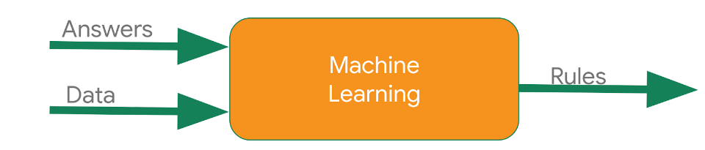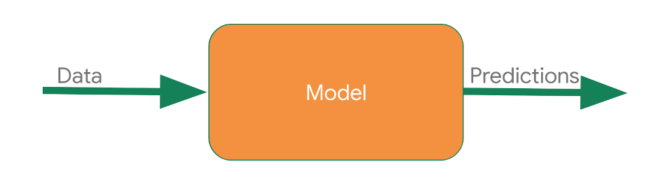

Figure 1.1 ML Model

In contrast to manually defining conditions for each activity, ML enables the development of models that learn from patterns in the data to make predictions. For instance, by feeding the system with data labelled as walking, running, or cycling, the model can infer the distinguishing features of each activity. The result is a model capable of making accurate predictions on new, unseen data, handling complexities beyond traditional programming approaches.
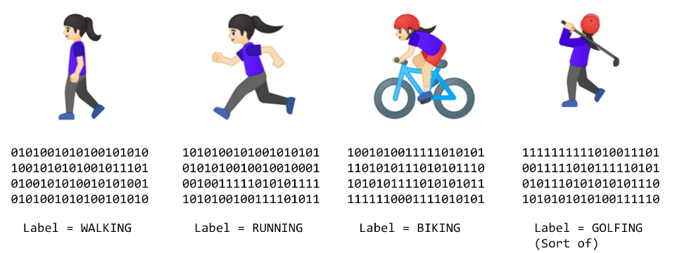

Figure 1.2 Activity Detection Scenario

INTRODUCTION TO COMPUTER VISION

In the task of image classification, a neural network is employed to recognize and categorize images from the Fashion MNIST dataset, which contains 70,000 grayscale images of clothing items across 10 categories, including T-shirts, trousers, and sneakers. The objective is to train a model that can effectively learn from these images and accurately classify new, unseen data. To prepare the data, the dataset is divided into training and testing sets, consisting of 60,000 and 10,000 images, respectively. Each image is normalized by scaling pixel values from a range of 0-255 to 0-1, facilitating faster convergence during the training process.
The neural network model is constructed using TensorFlow's Sequential API, incorporating three layers: a Flatten layer to convert the 28x28 pixel images into a one-dimensional vector, a Dense hidden layer with 128 neurons employing the ReLU activation function, and a Dense output layer with 10 neurons that uses the softmax activation function to produce a probability distribution over the classes. After compiling the model with an appropriate optimizer and loss function, it is trained on the prepared dataset.

The performance is evaluated using the test set, ensuring that the model generalizes well and accurately predicts clothing categories it has not previously encountered.

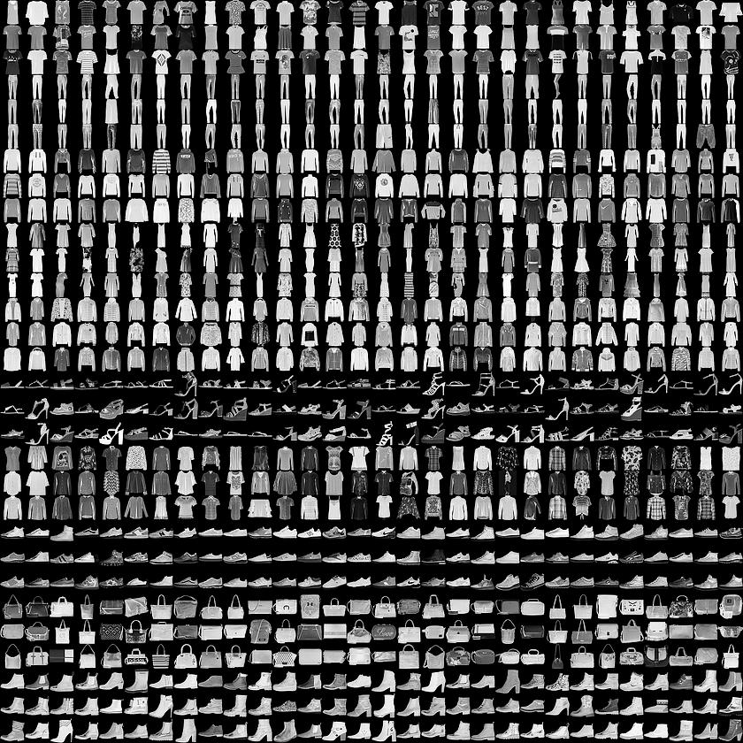

Figure 1.3 Fashion MNIST dataset

INTRODUCTION TO CONVOLUTIONS
In image processing, a convolution is a critical operation that involves applying a filter (or kernel) over an image to extract essential features. This process allows the model to recognize important aspects while blurring out less relevant details. For instance, to detect a sneaker in an image of a person wearing one, the program must effectively map the features of the sneaker by scanning pixel values and their neighbors, multiplying them by corresponding weights defined in the filter. A common practice is to utilize a 3x3 convolution matrix to calculate new pixel values based on neighboring pixels. After applying the filter, the resulting image emphasizes the crucial features, such as edges and lines, allowing for better recognition.

Following the convolution process, pooling techniques such as Max Pooling further enhance feature detection while reducing the image's dimensionality. By examining each pixel alongside its immediate neighbors and selecting the maximum value, the new image retains key features but is reduced to one-fourth of its original size. This reduction aids in minimizing computational complexity while preserving important details necessary for classification tasks. The resulting image from the pooling process will show significant features, demonstrating the effectiveness of both convolution and pooling in image processing tasks, such as recognizing patterns and objects within images.

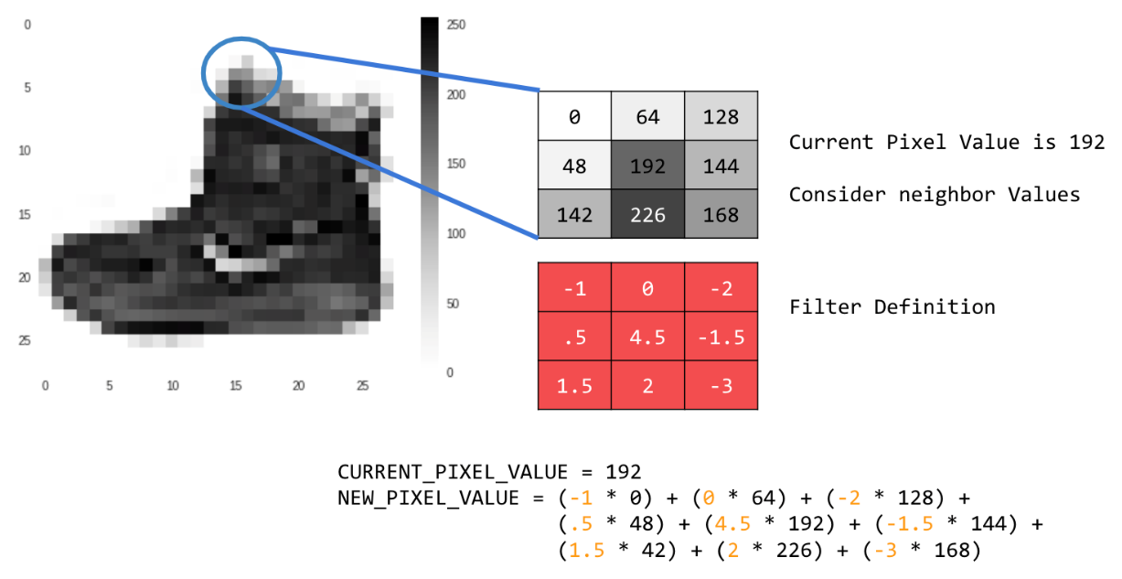

Figure 1.4 Convolution matrix of the image

CONVOLUTIONAL NEURAL NETWORKS(CNNs)

Incorporating convolutional layers into Deep Neural Networks (DNNs) significantly enhances fashion image recognition accuracy. A basic DNN can achieve around 89% training accuracy, but with the addition of convolutional layers, this can rise to approximately 93% for training and 91% for validation. This approach allows the model to focus on essential features, effectively narrowing down the amount of data processed. By visualizing the convolutions, distinct characteristics, such as shoe soles, become recognizable, illustrating the network's capability to generalize from the training dataset.
The process begins with reshaping the input data to fit the model's requirements, followed by adding convolutional layers that emphasize relevant features. Max pooling layers help compress the image while retaining critical details, further refining the model's focus. The final output layers consist of dense layers that classify the images based on the highlighted features. This structured approach leads to improved performance and accuracy, making it a powerful technique in image recognition tasks.

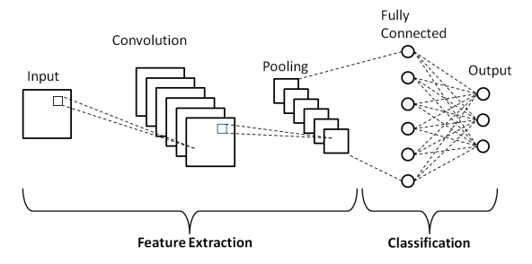

Figure 1.5 Convolutional Neural Networks

COMPLEX IMAGES
In this codelab, participants work with the well-known Cats and Dogs dataset provided by Microsoft, aiming to develop a convolutional neural network (CNN) to classify images accurately. After setting up the environment and downloading the dataset, the images are organized into training and testing directories. A crucial step is to split the dataset into training and testing sets, ensuring that the model can learn effectively without overfitting. The code includes functions to handle data preparation, including checking for zero-length images that may disrupt the training process.
The model is defined using a series of convolutional and pooling layers, facilitating the extraction of features from the images. Once compiled, the model is trained using the ImageDataGenerator, which rescales pixel values for improved performance. After training, the model's accuracy and loss are plotted to visualize its performance, helping to identify any signs of overfitting. Lastly, users can upload their images to test the model, providing an interactive way to see how well the trained CNN can classify new images as either cats or dogs.

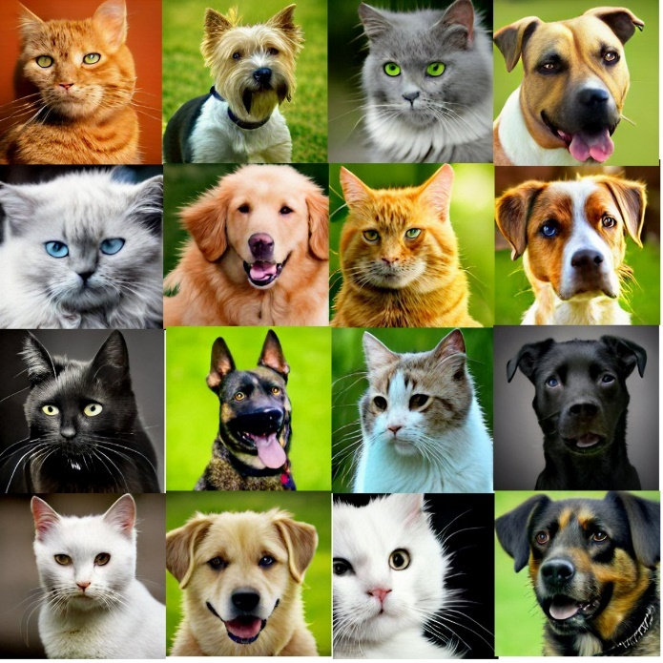

Figure 1.6 Cats and Dogs Database

1.6 USE CNNS WITH LARGER DATASETS

To build a horses-or-humans classifier, the process begins with downloading a dataset containing images of both classes. The images are then extracted and organized into directories for horses and humans, simplifying labeling, as an ImageDataGenerator can automatically assign labels based on directory names. Next, the dataset is explored visually to understand its characteristics, such as various poses and orientations. A convolutional neural network (CNN) is then defined using TensorFlow, featuring convolutional, pooling, and dense layers. The model is compiled with binary cross-entropy loss and the RMSprop optimizer for binary classification. Training is done in batches over several epochs, and the model's performance is evaluated using accuracy and loss metrics. Finally, the model is tested on new images to determine whether the content is a horse or a human, demonstrating its ability to generalize beyond the training data.

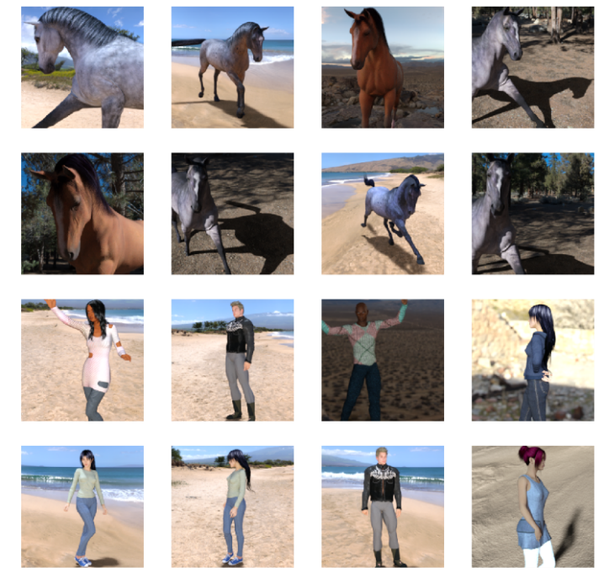

Figure 1.7 Horses and Humans Dataset

This is the badge obtained after completing the 1st chapter/unit:

Program Neural Networks with Tensorflow.


Figure 1.8 Program Neural Networks with Tensorflow Badge

GET STARTED WITH OBJECT DETECTION

INTRODUCTION TO OBJECT DETECTION
Object detection is a computer vision technique that analyzes images and identifies objects within them, providing both the object’s identity and its location using a bounding box. Unlike image classification, which only provides a list of detected objects, object detection specifies where these objects are within the image. Additionally, image segmentation is a more advanced approach, which not only detects object locations but also outlines them with pixel-precise masks.
Object detection has numerous practical applications, from detecting empty parking spots to identifying road issues like potholes. Developers can integrate this feature into apps using either pre-trained models for general objects or custom-trained models for domain-specific objects. Tools like TensorFlow Lite’s Model Maker and ML Kit’s Object Detection API make it easier to train and deploy object detection models with minimal coding, though collecting training data may require more effort.

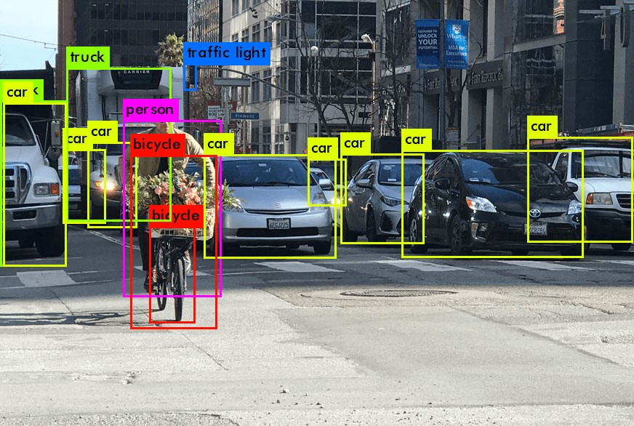

Figure 2.1 Object Detection

BUILD AN OBJECT DETECTOR INTO YOUR MOBILE APP

Object detection identifies objects within an image and their locations. By leveraging ML Kit’s Object Detection and Tracking API, it becomes easy to integrate object detection into mobile apps. This API allows the detection of prominent objects, specifying both their type and location in the form of bounding boxes. Developers can incorporate the API into their apps by adding a few lines of code, enabling features like multiple object detection and object classification.
The process begins by configuring the app’s build file, followed by initializing the inputImage and creating the ObjectDetection client with options for single image mode and multiple objects. Once an image is processed, the detection results are logged or visualized using bounding boxes and object labels. Visualization methods help display the detected objects on the app’s interface, offering a more interactive and informative experience. This method allows for rapid integration of object detection into mobile applications with minimal coding.
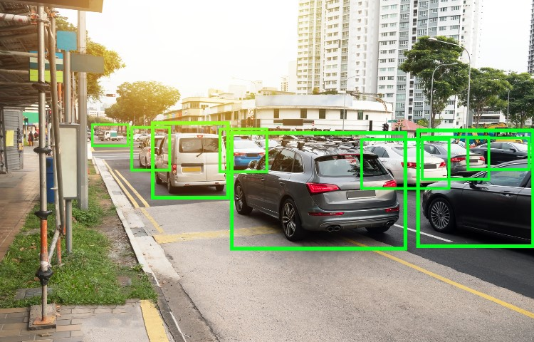
Figure 2.2 Object Tracking

INTEGRATE AN OBJECT DETECTOR USING ML KIT OBJECT DETECTION API

To integrate ML Kit Object Detection and Tracking API into an Android app, the process starts by downloading and importing the provided source code into Android Studio. After adding the necessary ML Kit dependencies to the build.gradle file and syncing with Gradle, the starter app can be run, allowing users to take photos or select preset images for object detection.

The object detection functionality is implemented in the runObjectDetection method. It involves creating an InputImage from a Bitmap, initializing the object detector with options for multiple objects and classification, and processing the image. The results include bounding boxes, labels, and confidence scores, which are visualized and displayed on the app's interface.

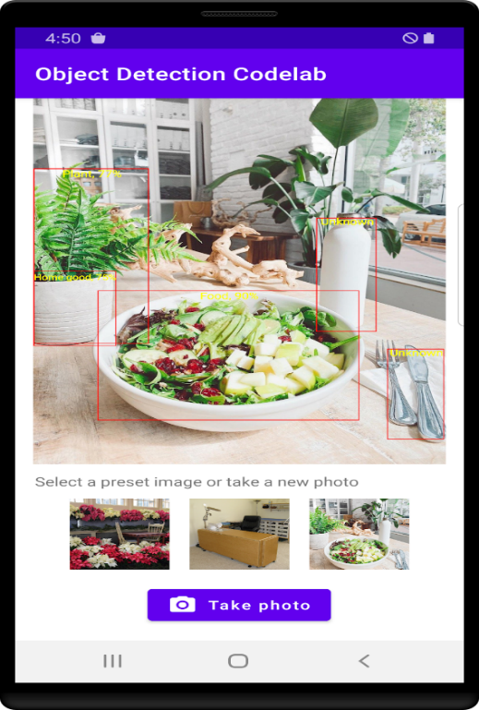
Figure 2.3 Mobile app for Object Detection
This is the badge obtained after completing the 2nd chapter/unit:
Get started with Object Detection.


Figure 2.4 Get started with Object Detection Badge

GO FURTHER WITH OBJECT DETECTION

TRAIN YOUR OWN OBJECT-DETECTION MODEL

Object detection is a computer vision task that identifies objects in an image and determines their location. To train and deploy a custom object detection model on a mobile app using TensorFlow Lite, three steps are involved: collecting and labeling training images, training the model with TensorFlow Lite Model Maker, and integrating the model into the app using TensorFlow Lite Task Library. Pre-trained models may recognize general objects, but custom models can be trained to detect specific objects like tomatoes or cheese.

To begin, collect images containing the objects of interest, label them, and define bounding boxes for each object. Model Maker simplifies the training process, allowing the use of EfficientDet-Lite models optimized for mobile devices. Once trained, the model is exported in TensorFlow Lite format and integrated into a mobile app. The TensorFlow Lite Task Library enables adding the model with minimal code. The app can then detect and visualize objects, ensuring performance by running the detection code on a background thread to avoid UI blocking.

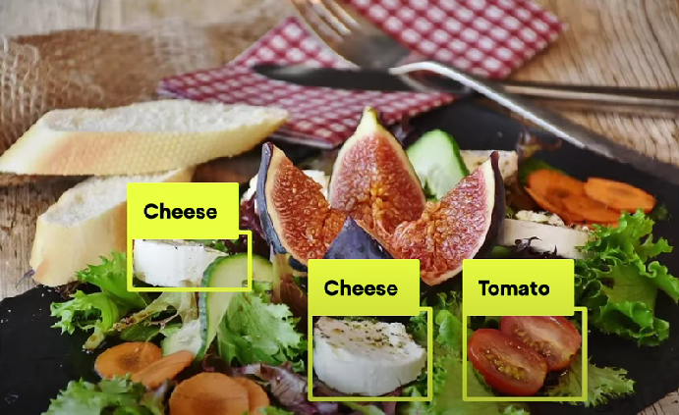

Figure 3.1 Custom model

BUILD AND DEPLOY A CUSTOM OBJECT-DETECTION MODEL WITH TENSORFLOW LITE

- TensorFlow Lite Overview: TFLite is optimized for mobile devices, and it allows for the training and deployment of machine learning models on Android or iOS. TFLite powers models in ML Kit, which can run object detection tasks like identifying everyday objects (cars, fruits, etc.).

    - Pre-trained Models: For general object detection, pre-trained models such as EfficientDet-Lite (trained on COCO dataset) can be easily integrated into mobile apps. These models can detect common objects and perform well on mobile CPUs and GPUs.

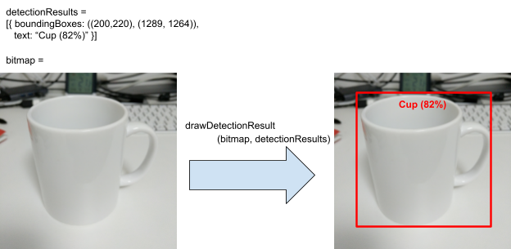

Figure 3.2 Result of Detection

- Mobile App Setup: The guide walks through importing starter code in Android Studio, running the app on an emulator or physical device, and using a TFLite pre-trained model to detect objects from an image. It covers using the ObjectDetector API to load a model, process images, and display detection results (bounding boxes and confidence scores) on the UI.

- Custom Model Training: If the pre-trained model doesn't meet specific needs, you can train a custom object detection model using Google Colab. A salad detection model is used as an example, and once trained, it can be integrated into the app for detection of specific objects.

- Model Integration: After training, the custom model (in TFLite format) is added to the mobile app, replacing the pre-trained model. This enables the app to detect domain-specific objects (like ingredients in a salad) instead of general objects.

- Running on Devices: The app can run on both emulators and physical devices, though performance is optimized for physical devices, where TFLite quantized models run much faster.

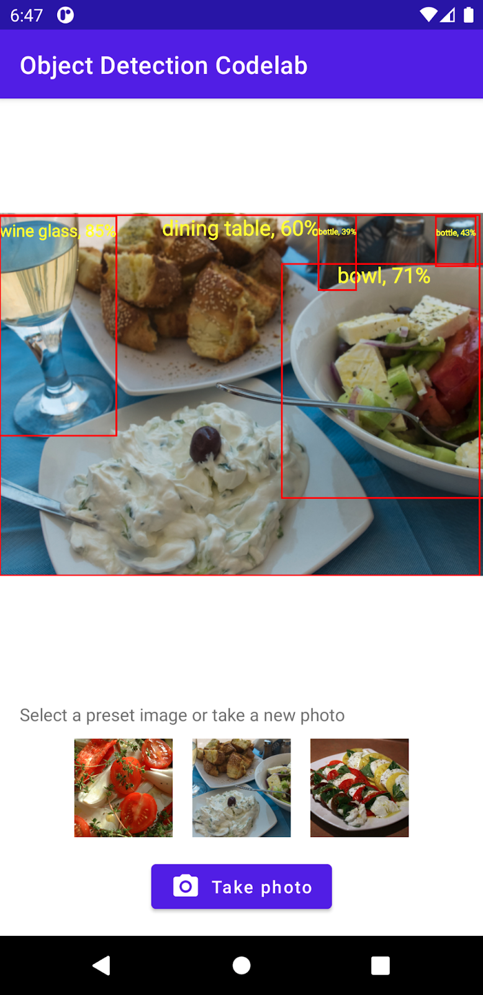

Figure 3.3 Result in the app

This is the badge obtained after completing the 3rd chapter/unit: Go further with object detection.



Figure 3.4 Go further with object detection badge

GET STARTED WITH PRODUCT

IMAGE SEARCH

INTRODUCTION TO PRODUCT IMAGE SEARCH ON MOBILE

To build a product image search feature in a mobile app, the process can be broken down into two key components: an on-device object detector and a product search backend.

Building a product image search feature in a mobile app involves two key components. First, an on-device object detector identifies prominent items within a photo. The user can select an object they want to search for, such as a shoe or a handbag. The app highlights the object with a bounding box to confirm what the user wants to search.

Next, the image of the selected product is sent to a backend server for visual search. This backend, typically using a tool like Google Vision API Product Search, matches the object with similar items in an online product catalog. The results are displayed to the user, offering shopping options from various online stores.

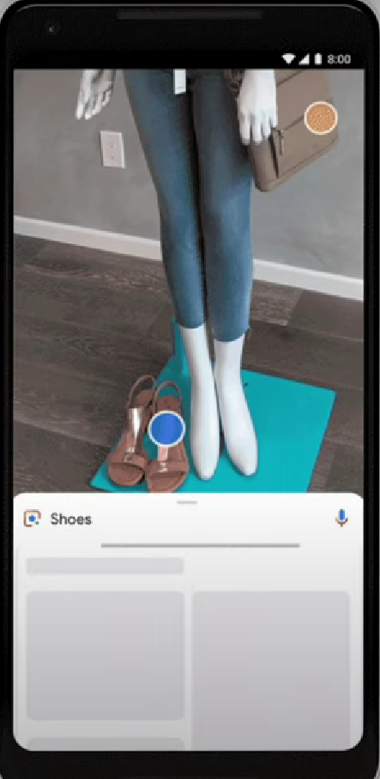

Figure 4.1 Product Image Search in Mobile

BUILD AN OBJECT DETECTOR INTO YOUR MOBILE APP

In this learning pathway, we explore how to integrate a product image search feature into a mobile app using ML Kit’s Object Detection and Tracking API. This API helps detect multiple objects from an image, allowing users to select the one they want to search for in your product catalog. After detecting objects, we can show them on the screen with bounding boxes, allowing users to choose which object they want to explore further. The setup requires adding ML Kit dependencies, writing object detection code, and enabling features like multiple object detection and classification to ensure relevant items, such as fashion goods, are recognized.

Once the detection is complete, the API provides a list of detected objects with bounding boxes and confidence scores for each. These bounding boxes are then displayed on the app interface, where users can tap to select the item they want to search for. The process is simple and involves feeding the input image to the object detector and drawing the detected object on the app’s UI. The goal is to make it easier for users to find similar products in your catalog.

In the next steps, the learning pathway dives deeper into implementing a product search backend using Vision API Product Search. By linking the detected object to your catalog, you can offer visually similar products directly to users. Detailed design guidelines for object detection interfaces are available in the Material Design section, helping developers create an intuitive and seamless app experience.

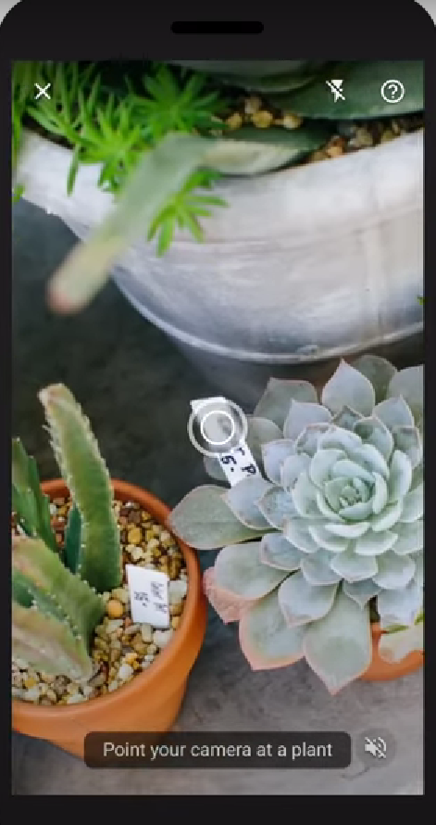

Figure 4.2 Object Detection

DETECT OBJECTS IN IMAGES TO BUILD A VISUAL PRODUCT SEARCH: ANDROID

This codelab demonstrates the process of building a product image search feature similar to Google Lens into a mobile application. The focus is on integrating ML Kit's Object Detection and Tracking API, which allows an app to detect multiple objects within an image. This capability enables a mobile app to let users capture photos, highlight objects, and select specific items for further searches in a product catalog.

The final application includes the ability to either capture images through the camera or select preset images from the device's gallery. Once an image is selected, the app uses the ML Kit API to detect objects, displaying them on the screen with bounding boxes. Users can then interact with these detected objects, selecting the one they wish to search for in the product database, providing a foundation for building product recommendation features.

This tutorial emphasizes the integration of ML Kit SDK in Android development using Kotlin. By following the steps provided, developers can quickly implement object detection functionality, allowing for bounding boxes and confidence scores to be displayed. The project structure helps in understanding how to apply machine learning techniques with minimal code while focusing on object detection and user interaction within an app.

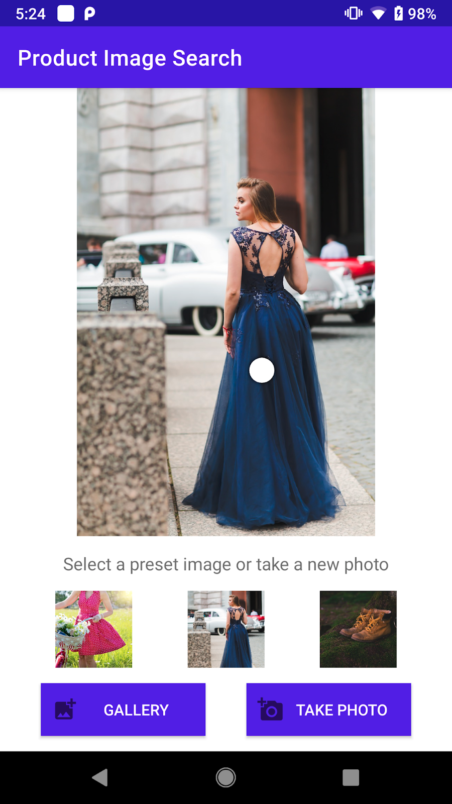

Figure 4.3 Product Image Search App

OBJECT DETECTION: STATIC IMAGES
This is an article that discusses the implementation of object detection using machine learning for static images. It explains how photographs can be utilized to identify and search for objects in the physical world, such as plants or products, by leveraging the **ML Kit Object Detection & Tracking API**. This API’s static mode can detect up to five objects in a provided image, which can then be linked to search results based on an image classification model.

The guidance includes principles for designing a seamless user experience. For example, it is recommended to use clear and legible images, align UI components effectively, and provide feedback during the search process. Components like object markers, tooltips, and result cards are used to display detected objects and their associated search results, enhancing interaction and clarity.

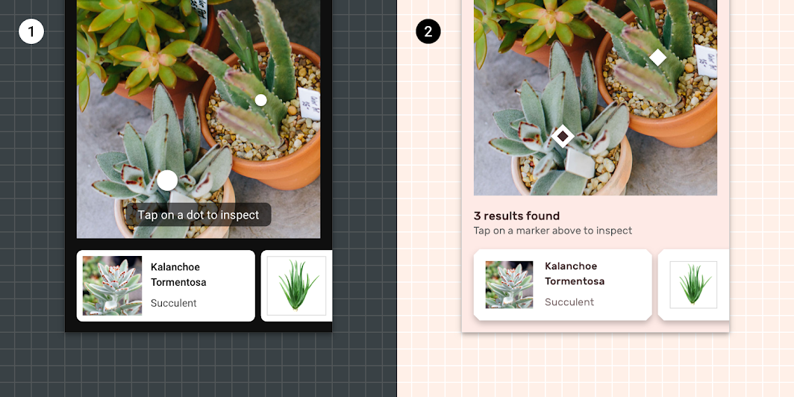

Figure 4.4 Object markers in Shrine

Key stages of the visual search process are outlined, including image selection, object recognition, and result communication. The app should guide users with tooltips, provide progress indicators, and use markers and cards to display search outcomes. The API supports the use of confidence scores to assess the reliability of the results, ensuring users are informed of low-confidence outcomes and given options to retry or seek help.

OBJECT DETECTION: LIVE CAMERA

Object detection using a live camera feed is a powerful feature that allows applications to identify objects in the physical world in real time. ML Kit’s Object Detection & Tracking API, in its "streaming" mode, can be utilized to detect objects from a live camera feed and use these detections for various purposes, such as performing a visual search. Visual searches use an image as input rather than text, which can be especially helpful for identifying objects in environments such as museums or stores. This technology offers a seamless way to enhance user interaction by detecting and analyzing objects without requiring them to type or search manually.

One of the core elements of this setup is the reticle, a visual guide that informs the user when the camera is actively detecting objects. Inspired by viewfinders in traditional cameras, the reticle typically uses a pulsing animation to signal object detection. It can also change its state based on feedback—indicating when an object is detected or when the camera needs adjustments (like moving closer to the object). Another important UI element is the object marker, which highlights the largest or most prominent object detected in the camera’s field of view. If the object is not adequately captured due to distance or size, only the corners of the detection rectangle will be shown, prompting the user to reposition the camera for better accuracy.

Tooltips play a crucial role in guiding users during the detection process. These text-based prompts appear at various stages of the detection flow to provide information or instructions, such as "Move closer" or "Searching…". Tooltips, however, are non-actionable, meaning users cannot interact with them directly.

When an object is successfully detected, a cropped version of the detected object’s image is displayed. This visual feedback allows users to confirm the object identified by the app, which can then be used for further actions, such as running a search or comparison.

The overall detection process occurs in three stages: Sense, Recognize, and Communicate. During the sensing stage, the app uses the live camera feed to scan for objects. The app should provide visual and animated cues, such as a pulsing reticle, to guide the user on how to interact with the camera. In the recognition stage, when an object is detected, it is visually marked (often with a border) to signal its identification. At this point, the app may prompt the user to start a search or further engage with the detected object. Finally, in the communication phase, the app presents search results or additional information, often through a modal bottom sheet that displays results based on the object’s detected confidence level.

For a smooth user experience, the interface should be designed to be minimal and unobtrusive. UI elements like the reticle and tooltips should not block the camera’s live feed, and feedback should be delivered promptly to guide users in optimizing object detection. Additionally, error states, such as poor lighting or network issues, should be handled gracefully with banners and clear instructions on how to resolve the problem. For example, if the camera cannot detect an object, the reticle’s animation should stop, and the app should display a help message or prompt the user to adjust the environment.

This framework of object detection with a live camera can be easily implemented using ML Kit’s API, which offers comprehensive support for Android and iOS platforms. Developers can customize the detection and search functionalities according to their specific use case, ensuring an intuitive and responsive user experience.

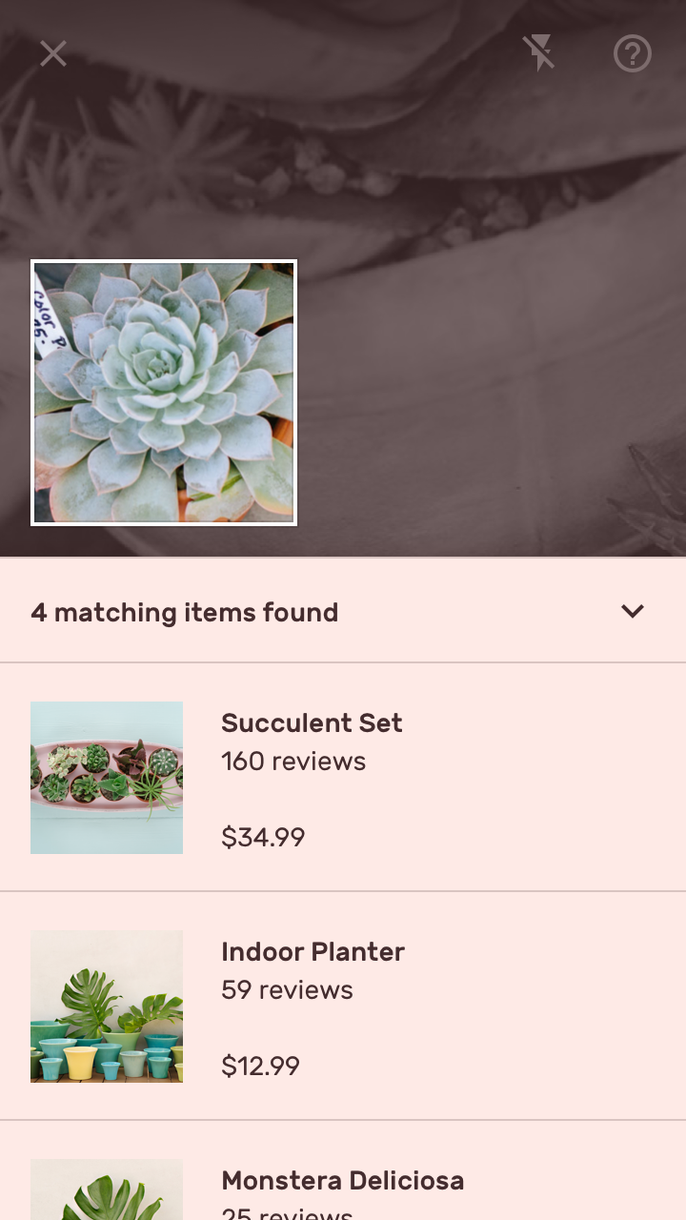

Figure 4.5 Results of the Object Detection

This is the badge obtained after completing the 4th chapter/unit:
Get started with product image search.

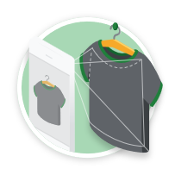

Figure 4.6 Get started with product image search badge

GO FURTHER WITH

PRODUCT IMAGE SEARCH

CALL THE PRODUCT SEARCH BACKEND FROM THE MOBILE APP

During my internship, I worked on implementing a product image search feature that allows users to search for visually similar products based on images. This involved integrating a product search backend using the Google Cloud Vision API Product Search. The project was structured in a learning pathway, where the first step was to build an object detector that enabled users to select the object they wanted to search for. Once the object was identified, the application could send a query to the product search backend, which would return visually similar products from a predefined product catalog.

The backend for the product search feature was deployed on Google Cloud, and I had to work with key identifiers like the Project ID, Location ID, and Product Set ID. A product set acts as a container for a group of products, with each product having reference images to enable more accurate image matching. The Vision API Product Search was used to match objects in images with products in the catalog. For instance, reference images of a dress from multiple angles (front and back) were utilized to ensure more precise search results. By using the proxy endpoint, the app could forward the product search request with necessary authentication and return the response to the app seamlessly.

One of the main challenges was working with the Google Cloud Vision API and ensuring that the product search results were accurate and efficient. The backend’s demo catalog had a limited number of products, which sometimes led to suboptimal search results if the query image did not match any of the catalog items. However, using the Vision API's product search allowed us to query the catalog efficiently and retrieve relevant results, which could be improved further by expanding the catalog. I used libraries like Volley for making HTTP requests and the Android task library for handling API responses, ensuring that the app remained responsive and user-friendly.

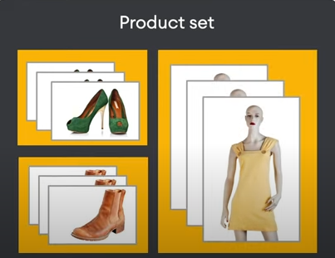

Figure 5.1 Product set

CALL THE PRODUCT SEARCH BACKEND FROM THE ANDROID APP

This codelab focuses on integrating Google Cloud's Vision API Product Search into an Android application, allowing users to search for visually similar products based on images. The application utilizes ML Kit Object Detection and Tracking to identify and display objects in user-uploaded or camera-captured images. Users can tap on a detected object, signaling their intent to conduct a product search for that specific item. This functionality is streamlined through a callback method, which retrieves the cropped image of the selected object for further processing.

After an object is selected, the app saves the cropped image as a PNG file to preserve quality while complying with Android's intent bundle size limitations. The URI of this image is then passed to a new activity, ProductSearchActivity, where the image is displayed and prepared for search queries. This approach enhances user interaction by enabling the precise identification of specific items and demonstrates the effective integration of machine learning capabilities and cloud-based APIs within mobile applications, offering a robust solution for visual product searches.
The codelab demonstrates the integration of Google Cloud's Vision API Product Search within an Android application, enabling users to search for visually similar products using images captured or uploaded on their devices. By leveraging ML Kit Object Detection and Tracking, the application identifies objects within images, allowing users to select a specific item for further product searches. Once an object is chosen, the app converts the cropped image into a base64 representation and sends it to the Vision API for analysis. The backend then returns a list of similar products, which the app displays to the user, showcasing the seamless blend of machine learning and cloud technology to enhance user experience in product discovery.

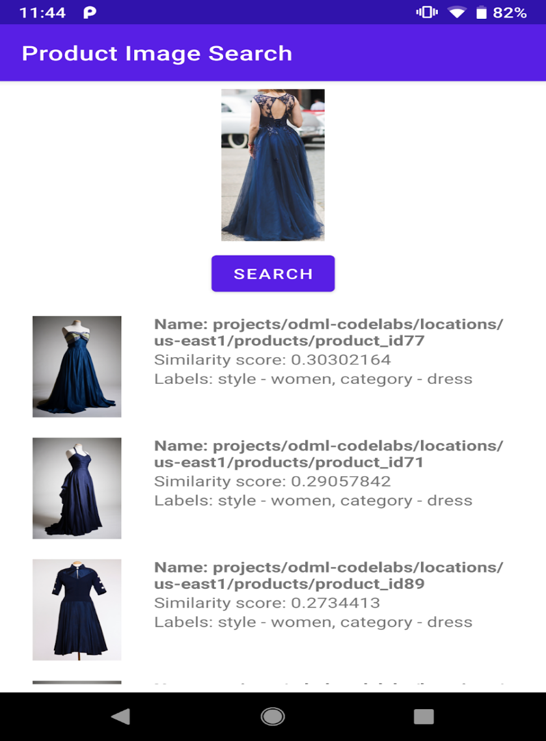

Figure 5.2 Product Reference Image

BUILD A VISUAL PRODUCT SEARCH BACKEND

USING VISION API PRODUCT SEARCH

In this codelab, you will learn how to build a product image search backend using Google Cloud's Vision API Product Search. This API enables retailers to create a catalog of products by associating reference images with each product from various viewpoints. By utilizing machine learning, the Vision API can match user-uploaded images with the products in your catalog, returning a ranked list of visually similar items. This functionality is invaluable for creating a seamless shopping experience, allowing users to find products they are interested in by simply uploading an image rather than searching through traditional text-based queries.

To get started, ensure you have a Google Cloud account with billing enabled. The initial step involves following the Vision API Product Search quickstart guide, where you will build a product search backend that takes an input image and returns similar products from your catalog. After successfully creating the backend, you will set up an API key to facilitate secure access to the Vision API from your mobile applications. It's essential to restrict the API key to prevent unauthorized access, which involves specifying the type of applications that can use it and restricting it to only allow calls to the Cloud Vision API.

Once your backend is set up and secured, you can integrate it into your mobile application. By downloading the provided Android app code and importing it into Android Studio, you will modify the API endpoint configurations to use your newly created backend instead of the demo version. After updating the API keys and project information in the code, you can run the application on your Android device. Users will then be able to upload images and receive search results based on visually similar products from your catalog, demonstrating the power of machine learning in enhancing product discovery in e-commerce.

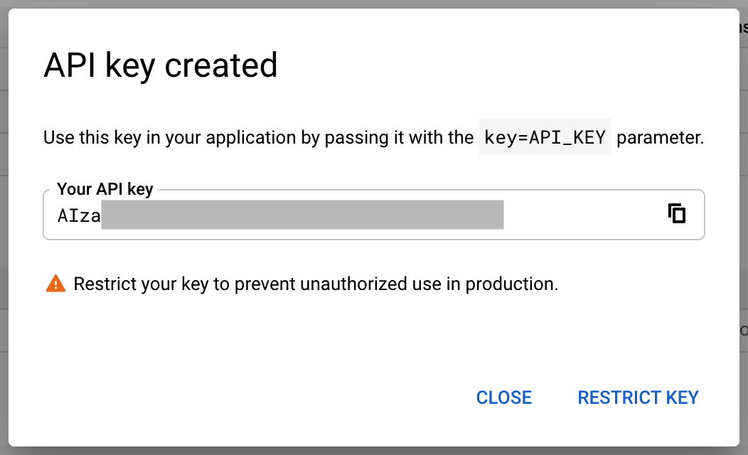
Figure 5.3 API key creation

This is the badge obtained after completing the 5th chapter/unit:
Go further with product image search.


Figure 5.4 Go further with product image search badge

GO FURTHER WITH IMAGE CLASSIFICATION

BUILD A FLOWER RECOGNIZER

During the internship, I learnt about the development of a specific image classifier app that can accurately identify different types of flowers, moving beyond generic classifications. The goal is to improve the model's precision so that it can distinguish between flower types, such as recognizing a daisy instead of simply categorizing it as a "plant with petals." To achieve this, a custom model is necessary, which requires feeding the neural network samples of each flower class, such as roses, daisies, tulips, sunflowers, and dandelions.

To build the model, I learnt about the importance of collecting a diverse set of training images organized into labeled folders for each class. Using Google Colab, a browser-based development environment, users can easily train their neural network without worrying about installing software. The Colab setup offers powerful GPU support, which speeds up the training process. TensorFlow Lite Model Maker is introduced as a tool to streamline the coding and training of the neural network, providing a simplified high-level API that reduces complexity for users who may not be expert programmers.

When the original base model is used, the app produces broad classifications like "flower" or "sky." However, once the custom model is implemented, the app demonstrates improved accuracy, correctly identifying specific flowers with high probability, such as a daisy with 95.9% certainty. The upcoming code labs will guide users through training their model and integrating it into their applications using ML Kit’s custom model APIs.
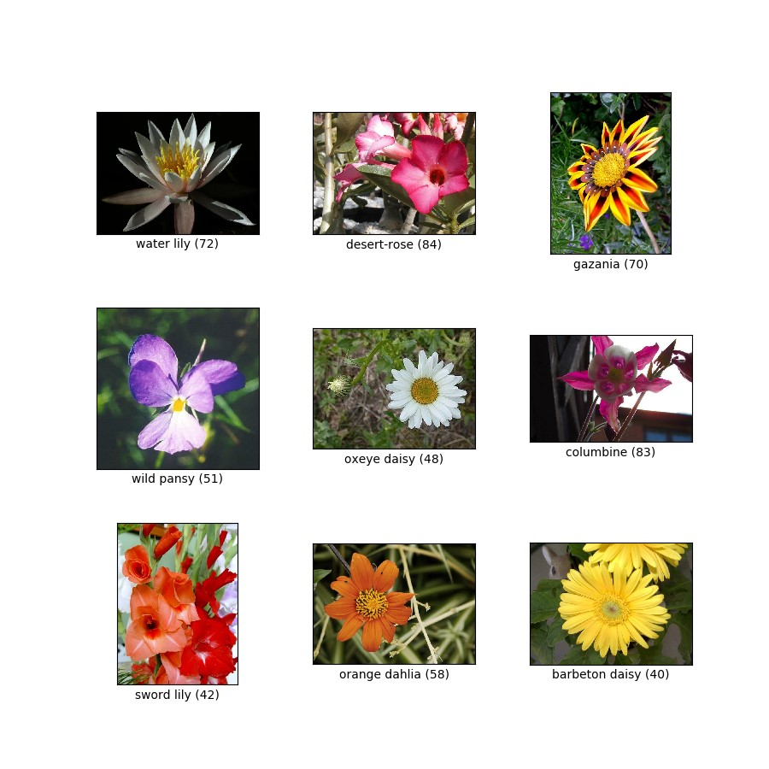

Figure 6.1 Flowers Dataset for Classification

6.2 CREATE A CUSTOM MODEL FOR YOUR IMAGE CLASSIFIER

The codelab guides users on how to enhance an image classifier app by training a custom model to recognize specific types of flowers, such as daisies and roses, instead of generic classifications like "flower" or "plant." Users are encouraged to utilize TensorFlow Lite Model Maker, which simplifies the model training process without requiring deep expertise in neural network design. The codelab assumes that users have completed a previous session on basic image labeling and that they have access to Google Colab for executing code.

To train the model, participants need a dataset of flower images organized into directories corresponding to each type of flower, which can be easily loaded into the training environment. To prepare the training data, users will download a pre-organized dataset of flower images from a specified URL and split it into training and test datasets. The TensorFlow Lite Model Maker abstracts complex details of neural network creation, allowing users to create a model with a single line of code. The training process employs transfer learning, utilizing a pre-trained model from TensorFlow Hub, specifically designed for image recognition tasks.

This approach enables the custom model to achieve high accuracy—93.85% after five training epochs—demonstrating its effectiveness at distinguishing between the various flower classes.
Once the model is trained, it can be evaluated for its performance on unseen data, providing an accuracy metric that helps users gauge its real-world applicability. The trained model can then be exported in the .tflite format, making it ready for integration into mobile applications. This step is straightforward within Google Colab, where users can access their exported model files and download them for further use. The codelab emphasizes the importance of understanding the basics of machine learning and provides resources for users who wish to delve deeper into the subject.

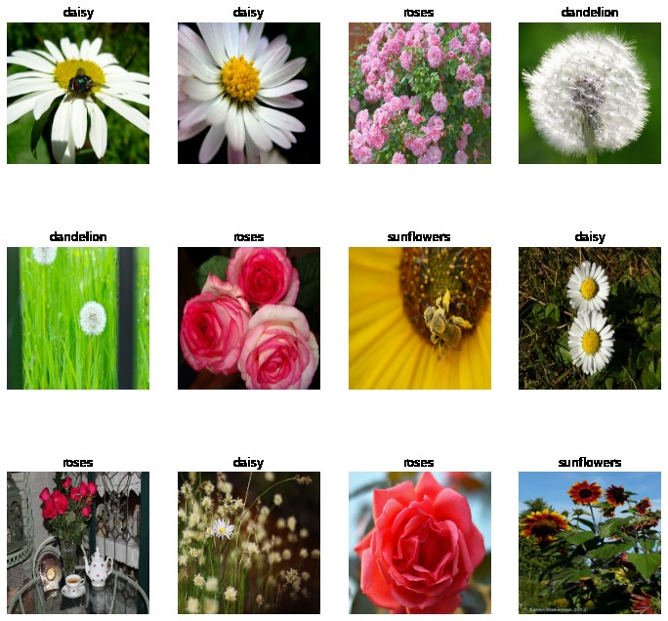
Figure 6.2 Image Classifier

6.3 INTEGRATE A CUSTOM MODEL INTO YOUR APP

Finally, I learnt how to update a flower recognition app by integrating a custom model trained to identify specific flower types, such as daisies and roses. The process builds on the previous codelabs, enhancing the app’s capabilities by utilizing a model tailored to recognize distinct categories of flowers. Before starting, it's important to complete the first two codelabs and ensure the appropriate development environments are set up: Android Studio for Android applications and Xcode for iOS applications.

For Android development, the project should be opened in Android Studio, and the app-level build.gradle file needs modification to include the custom image labeling dependency. The .tflite model must be added to the assets folder, and the MainActivity should be updated to load the custom model for classification.

For iOS development, the Podfile in Xcode should be updated to use the custom image labeling library, followed by running `pod install` and opening the .xcworkspace file. Once the workspace is open, drag and drop the model.tflite file into the project, ensuring it is added to the target. Then, modify ViewController.swift to import the necessary ML Kit modules, including the custom image labeling classes. Within the getLabels() function, code should be written to load the custom model from the app bundle, and the options for the image labeler must be updated to utilize the local model.

After these changes, running the app on a simulator or device will allow testing of the new functionality. By following these steps, the app will accurately classify flower images using the custom-trained model, enhancing its ability to recognize specific flower types like daisies and roses.

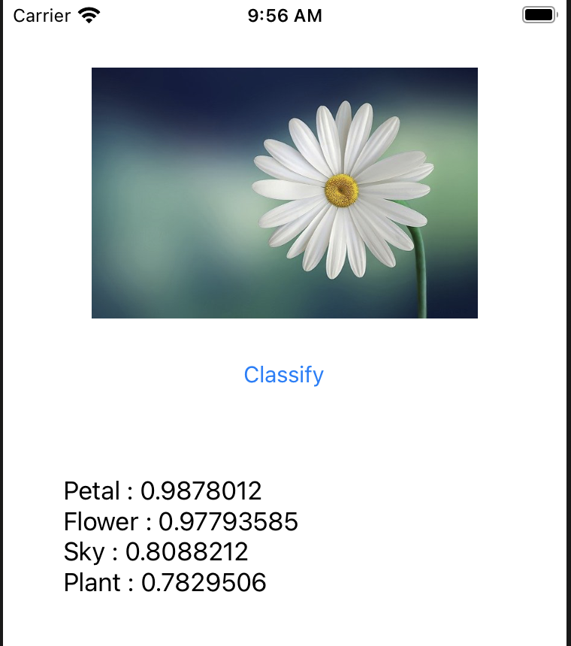

Figure 6.3 Result of Image Classifier

This is the badge obtained after completing the 6th chapter/unit:
Go further with image classification.

Figure 6.4 Go further with image classification badge

CONCLUSION

The summer internship on Artificial Intelligence - Machine Learning (AI-ML) provided a hands-on experience in developing and implementing machine learning models, with a focus on real-world applications. Through various projects, the internship explored critical aspects of AI such as convolutional neural networks (CNNs), object detection, and image classification, using tools like TensorFlow, TensorFlow Lite, and ML Kit. The projects covered essential machine learning workflows, including data preprocessing, model training, evaluation, and deployment on mobile platforms.

The internship began with a comprehensive understanding of neural networks and image-related tasks, leading to successful applications of CNNs in tasks like image classification and complex visual pattern recognition. Further, it delved into object detection techniques, integrating models such as SSD and YOLO into mobile apps. The development of a product image search feature demonstrated practical AI applications in e-commerce, where object detection was utilized to identify and match products with catalog items.

A significant takeaway was the ability to implement machine learning models on mobile devices, achieving on-device inference that is efficient and suitable for resource-constrained environments. The overall learning experience enhanced problem-solving skills and deepened the understanding of AI-ML technologies, setting a strong foundation for future endeavors in the field.

BIBILOGRAPHY

- Géron, Aurélien. Hands-On Machine Learning with Scikit-Learn, Keras, and TensorFlow.
O'Reilly Media, 2019.
- Goodfellow, Ian, et al. Deep Learning. MIT Press, 2016.
- Chollet, François. Deep Learning with Python. Manning Publications, 2018.
- Zhang, Zheng, et al. "A Comprehensive Survey on Mobile AI." IEEE Access, vol. 8,
2020, pp. 87563-87581.
- Redmon, Joseph, and Ali Farhadi. "YOLOv3: An Incremental Improvement." arXiv preprint arXiv:1804.02767 (2018).
- Howard, Andrew G., et al. "EfficientDet: Scalable and Efficient Object Detection.
"Proceedings of the IEEE/CVF Conference on Computer Vision and Pattern Recognition. 2020.

